

**VISVESVARAYA TECHNOLOGICAL UNIVERSITY**

**“JnanaSangama”, Belgaum -590014, Karnataka.**

**LAB RECORD**

**Computer Network Lab (23CS5PCCON)**

***Submitted by***

**Owais Ali Khadim Batti (1BM23CS221)**

***in partial fulfillment for the award of the degree of***

**BACHELOR OF ENGINEERING**

***in***

**COMPUTER SCIENCE AND ENGINEERING**

**B.M.S. COLLEGE OF ENGINEERING**

**(Autonomous Institution under VTU)**

**BENGALURU-560019**

**September 2025 – January 2026**



**B. M. S. College of Engineering,**

**Bull Temple Road, Bangalore 560019**

(Affiliated To Visvesvaraya Technological University, Belgaum)

**Department of Computer Science and Engineering**



**CERTIFICATE**

This is to certify that the Lab work entitled “Computer Network (23CS5PCCON)” carried out by **Owais Ali Khadim Batti (1BM23CS221),** who is bonafide student of **B.M.S. College of Engineering.** It is in partial fulfilment for the award of **Bachelor of Engineering in Computer Science and Engineering** of the Visvesvaraya Technological University, Belgaum. The Lab report has been approved as it satisfies the academic requirements of the above-mentioned subject and the work prescribed for the said degree.





Index

**Part - A**

| **Sl.**  **No.** | **Date** | **Experiment Title** | **Page No.** |
| --- | --- | --- | --- |
| 1 | 19/08/25 | Create a topology and simulate sending a simple PDU from source to destination using hub and switch as connecting devices and demonstrate  ping message. | 1 – 4 |
| 2 | 09/09/25 | Configure DHCP within a LAN and outside LAN. | 5 – 8 |
| 3 | 09/09/25 | Configure Web Server, DNS within a LAN. | 9 – 11 |
| 4 | 09/09/25 | Configure IP address to routers in packet tracer.  Explore the following messages: ping responses, destination unreachable, request timed out, reply. | 12 – 14 |
| 5 | 23/09/25 | Configure default route, static route to the Router. | 15 – 18 |
| 6 | 23/09/25 | Configure RIP routing Protocol in Routers. | 19 – 22 |
| 7 | 14/10/25 | Configure OSPF routing protocol. | 23 – 25 |
| 8 | 14/10/25 | To construct a VLAN and make the PC’s communicate among a VLAN. | 26 – 28 |
| 9 | 11/11/25 | To construct a WLAN and make the nodes communicate wirelessly. | 29– 32 |
| 10 | 11/11/25 | Demonstrate the TTL/ Life of a Packet. | 33 – 36 |
| 11 | 18/11/25 | To understand the operation of TELNET by accessing the router in server room from a PC in IT office. | 37– 41 |
| 12 | 18/11/25 | To construct simple LAN and understand the concept and operation of Address Resolution Protocol (ARP). | 42 – 45 |



**Part - B**

| **Sl.**  **No.** | **Date** | **Experiment Title** | **Page No.** |
| --- | --- | --- | --- |
| 1 | 28/10/25 | Write a program for congestion control using Leaky bucket algorithm. | 46 – 49 |
| 2 | 17/11/25 | Using TCP/IP sockets, write a client-server program to make client sending the file name and the server to send back the contents of the requested file if present. | 50 – 51 |
| 3 | 17/11/25 | Using UDP sockets, write a client-server program to make client sending the file name and the server to send back the contents of the requested file if present. | 52 – 53 |
| 4 | 28/10/25 | Write a program for error detecting code using CRC-CCITT (16-bits). | 54 - 58 |

Github Link:

https://github.com/OwaisBmsce/CN_LAB

# PART - A

**Program 1:**

**Aim:** Create a topology and simulate sending a simple PDU from source to destination using hub and switch as connecting devices and demonstrate ping message.

**Topology:**

1. STAR Topology with Switch: 2. MESH Topology with Switch:

3. HUB-Based Network Topology:

**Procedure:**

**1. Create STAR Topology Using a Switch**

1. Open Cisco Packet Tracer and go to the End Devices section.
2. Drag and drop PCs (PC0, PC1, PC2, PC3, PC4) into the workspace.
3. From Switches, drag a 2950-24 switch to the center.
4. Connect each PC to the switch using Copper Straight-Through cables:
   * PC0 → Switch (Fa0/1)
   * PC1 → Switch (Fa0/2)
   * PC2 → Switch (Fa0/5)
   * PC3 → Switch (Fa0/3)
   * PC4 → Switch (Fa0/4)
5. Assign IP addresses to PCs:
   * Go to PC → Desktop → IP Configuration
   * Enter the IP address/subnet for each PC (any address in same network).
6. Test connectivity:
   * Use Add Simple PDU tool to send a ping from one PC to another.

**2. Create MESH Topology Using Switches**

1. Drag and drop PCs (PC0, PC1, PC2, PC3, PC4).
2. Add two 2950-24 switches to the workspace.
3. Create mesh-style interconnections:
   * Connect each PC to the nearest switch.
   * Connect Switch1 ↔ Switch2 with multiple redundant links (e.g., Fa0/1 ↔ Fa0/3, Fa0/2 ↔ Fa0/4).
4. Assign IP addresses to all PCs within the same network.
5. Verify STP operation automatically blocks redundant paths.
6. Use Simple PDU (ICMP) to test ping between:
   * PC0 → PC3
   * PC1 → PC4
   * PC2 → any node
7. View packet movement under Simulation Mode.

**3. Create HUB-Based Topology**

1. Drag and drop PCs (PC5, PC6, PC7, PC8, PC9).
2. From Hubs section, drag a Generic Hub (Hub0).
3. Connect each PC to the hub using Copper Straight-Through cable:
   * PC5 → Hub Fa0
   * PC6 → Hub Fa1
   * PC7 → Hub Fa2
   * PC8 → Hub Fa3
   * PC9 → Hub Fa4
4. Assign IP addresses within the same network for all PCs.
5. Use Simulation mode to send Simple PDU.
6. Observe broadcast behavior:
   * Hub sends the packet to all devices.

**4. Demonstrate Ping Message (ICMP)**

1. Switch to Simulation Mode from bottom-right corner.
2. Select the Simple PDU Tool (envelope icon).
3. Click on Source PC, then Destination PC.
4. Playback controls:
   * Play to observe step-by-step
   * Fast Forward for quick simulation
5. Watch the ICMP request and reply in the Event List window

**Output:**

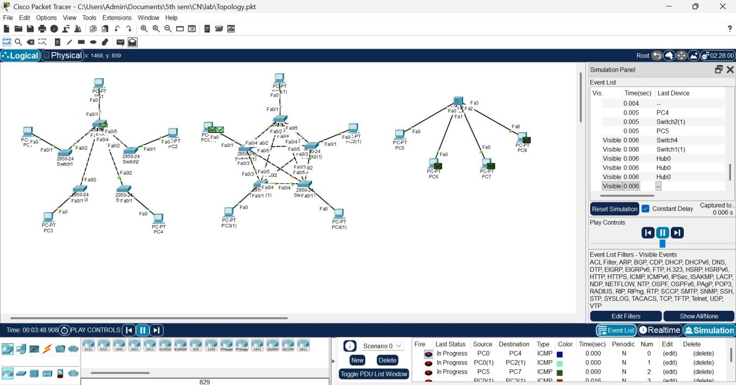

**Observation:**

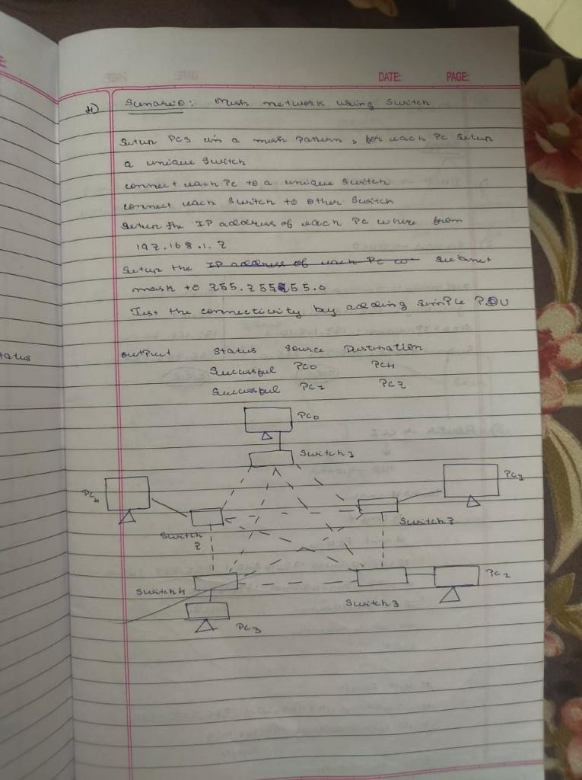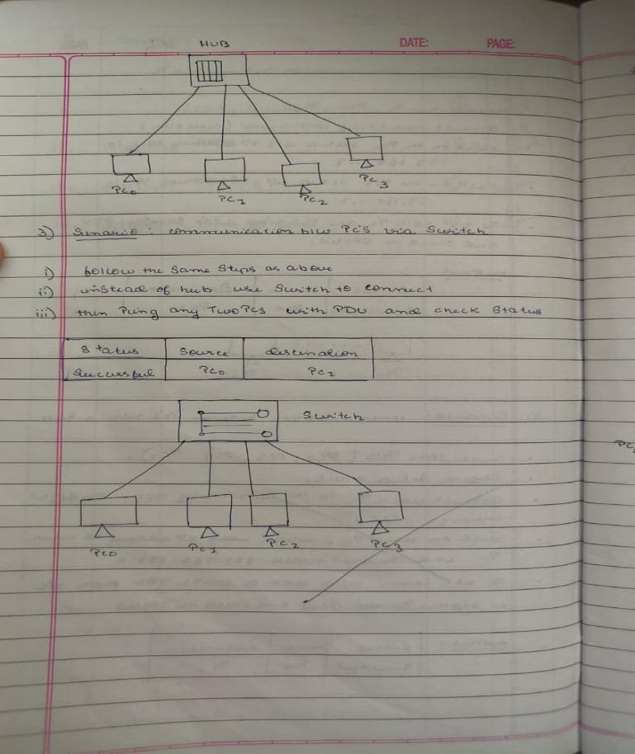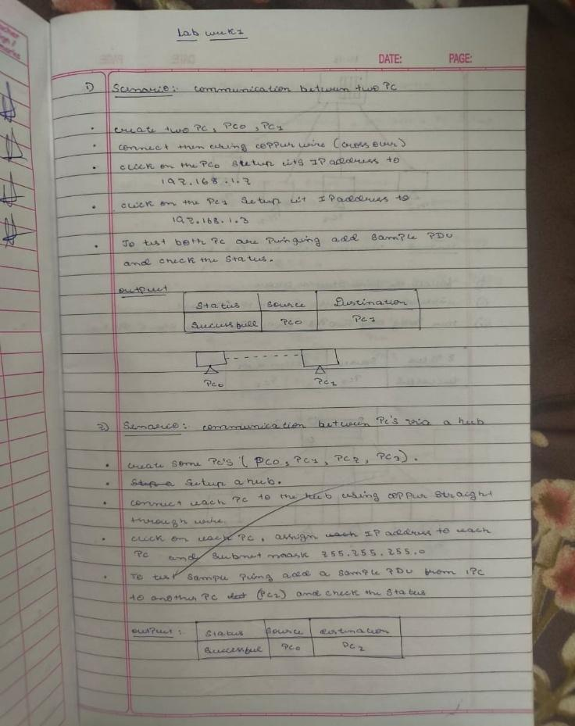

**Program 2:**

**Aim:** Configure DHCP within a LAN and outside LAN.

**Topology:**



**Procedure:**

1. **Configure DHCP Server:**in DHCP server go to Desktop>IP-Config, assign static IP – 192.168.10.2 and gateway 192.168.10.1
2. **Open Services>DHCP and add following two dhcp pool:**
3. Pool Name: switch1

Gateway: 192.168.10.1

Start Ip: 192.168.10.3  
Subnet Mask: 255.255.255.0  
Max Users: 20

1. Pool Name: switch2

Gateway: 192.168.20.1

Start Ip: 192.168.10.2  
Subnet Mask: 255.255.255.0  
Max Users: 20

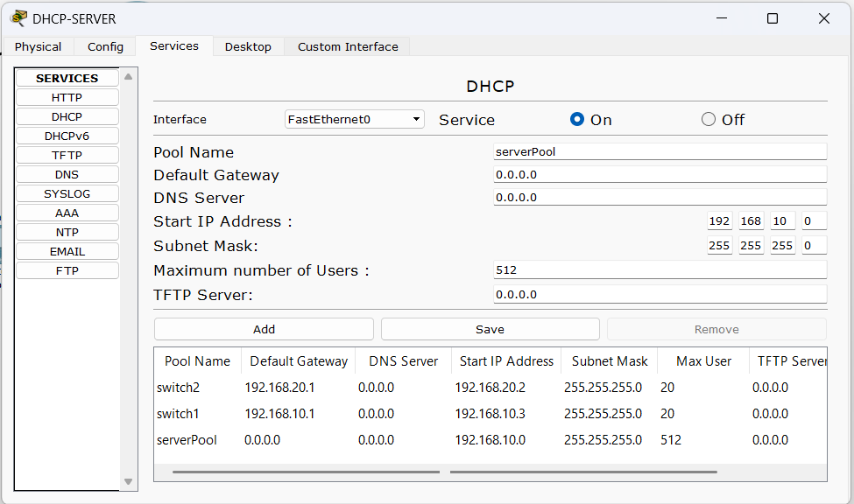

1. **Configure Router**
2. Router>enable
3. Router#configure terminal

(Within Lan)

1. Router(config)# int fa0/0
2. Router(config-if)# ip address 192.168.10.1 255.255.255.0
3. Router(config-if)# ip helper-address 192.168.10.2
4. Router(config-if)# no shutdown
5. Router(config-if)# exit

(Outside Lan)

1. Router(config)# int fa0/1
2. Router(config-if)# ip address 192.168.20.1 255.255.255.0
3. Router(config-if)# ip helper-address 192.168.10.2
4. Router(config-if)# no shutdown
5. Router(config-if)# exit
6. Router(config)# exit
7. Router# write memory

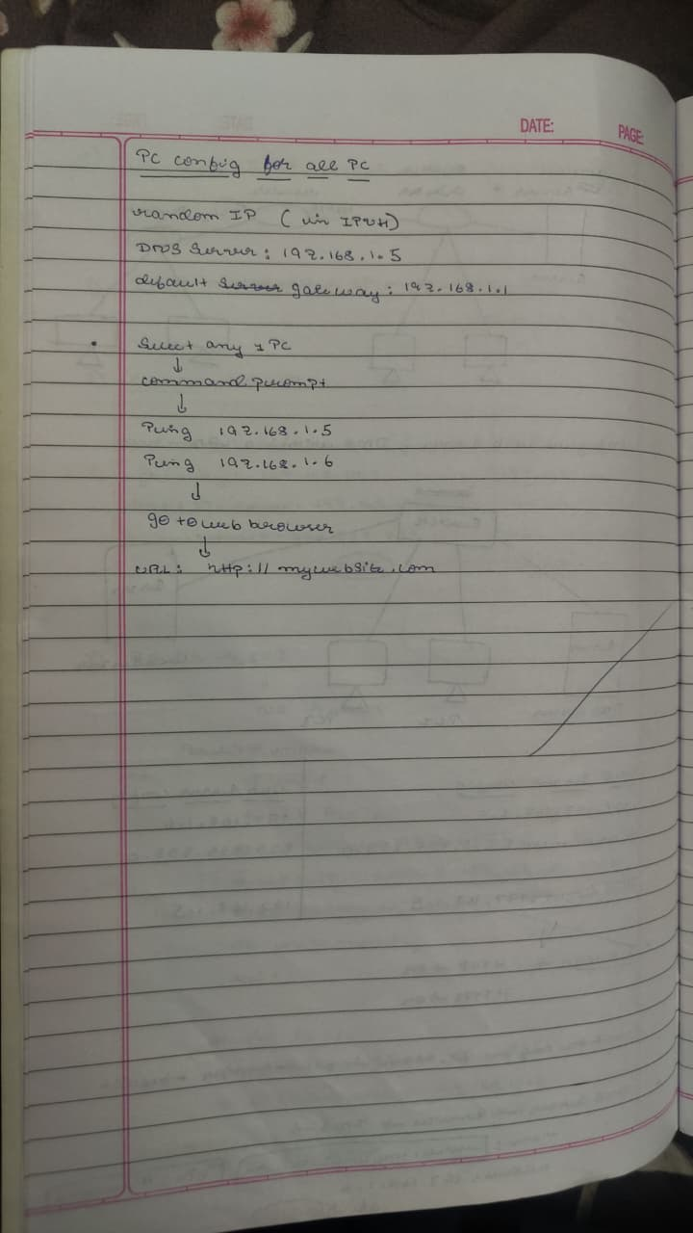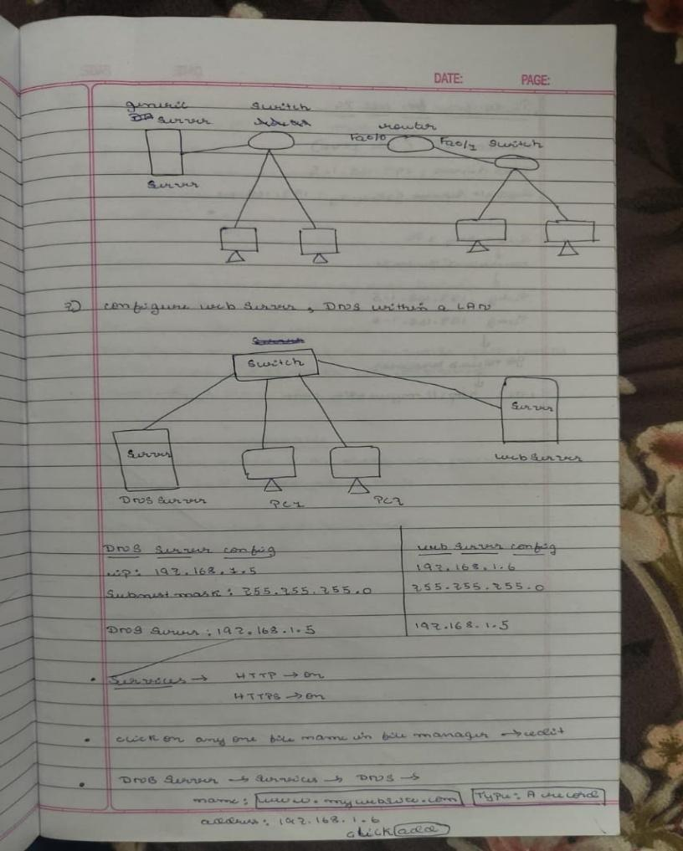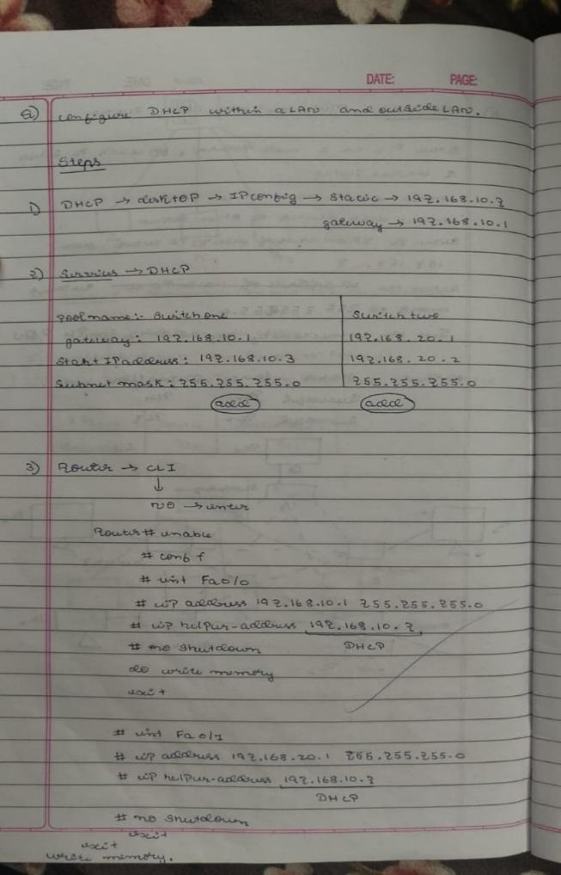 **Observation:**

**Output:**

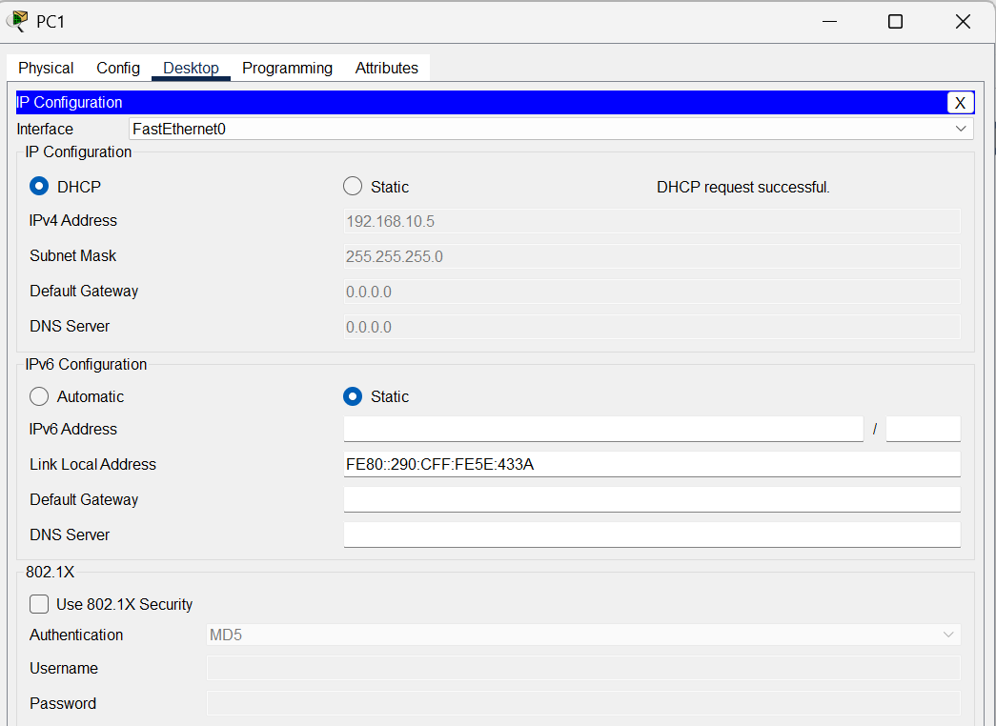

Fig 1. Ip address assigned by DHCP server within Lan (PC1)

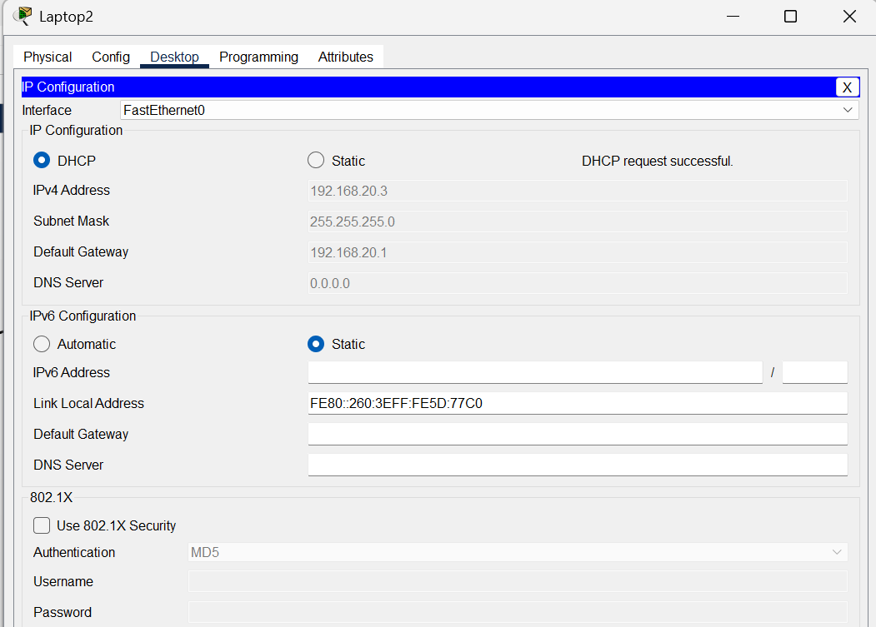

Fig 2. Ip address assigned by DHCP server outside Lan (laptop2)

**Program 3:**

**Aim:** Configure Web Server, DNS within a LAN.

**Topology:**



**Procedure:**

**1. Create the Network**

1. Place 1 Router, 1 Switch, 1 DNS Server, 1 Web Server, and two PCs.
2. Connect all devices using Copper Straight-Through cables.

**2. Assign IP Addresses**

1. On each device: Desktop → IP Configuration
   * Assign IPs in same network (e.g., 192.168.1.x).
   * Set Gateway = Router’s interface IP.

**3. Configure DNS Server**

1. Open DNS Server → Services → DNS.
2. Turn DNS Service = On.
3. Add A-Record:
   * Name: letslearn.com
   * Address: IP of Web Server
4. Click Add → Save.

**4. Configure Web Server**

1. Open Web Server → Services → HTTP.
2. Turn HTTP = On (HTTPS optional).
3. Ensure index.html exists (default file is fine).
4. Edit HTML if needed.

**5. Test from PC**

1. Open PC → Desktop → Web Browser.
2. Enter URL:
3. http://www.letslearn.com/index.html
4. The webpage should load, confirming DNS + Web Server working.

**Observation:**

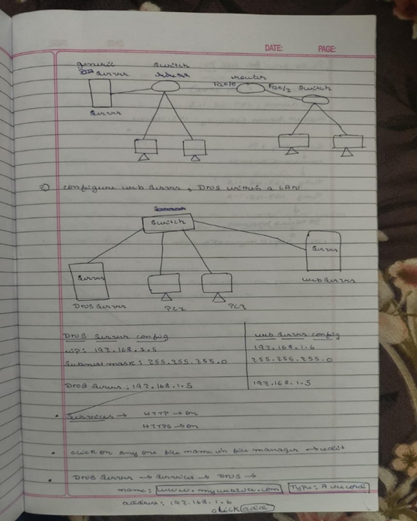

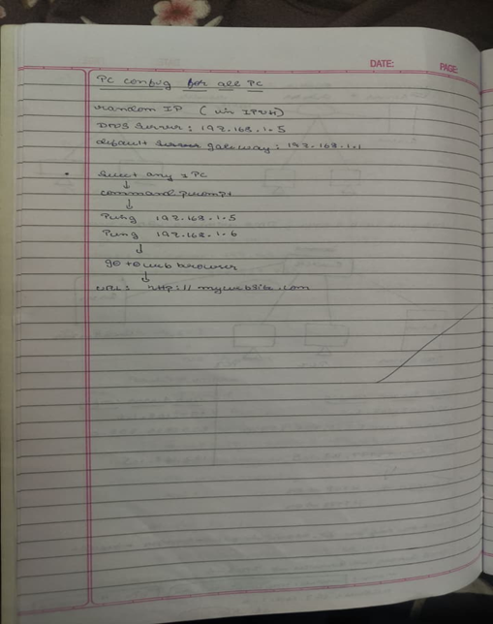

**Output:**

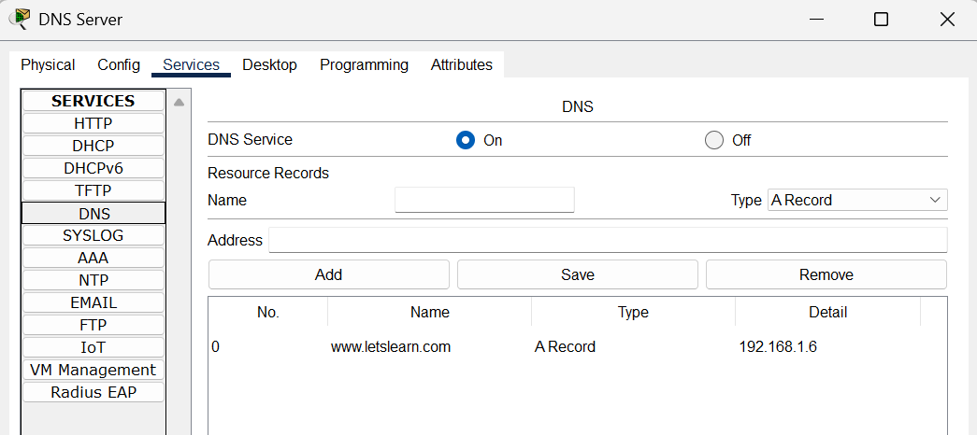

Fig 1. DNS server – DNS Services

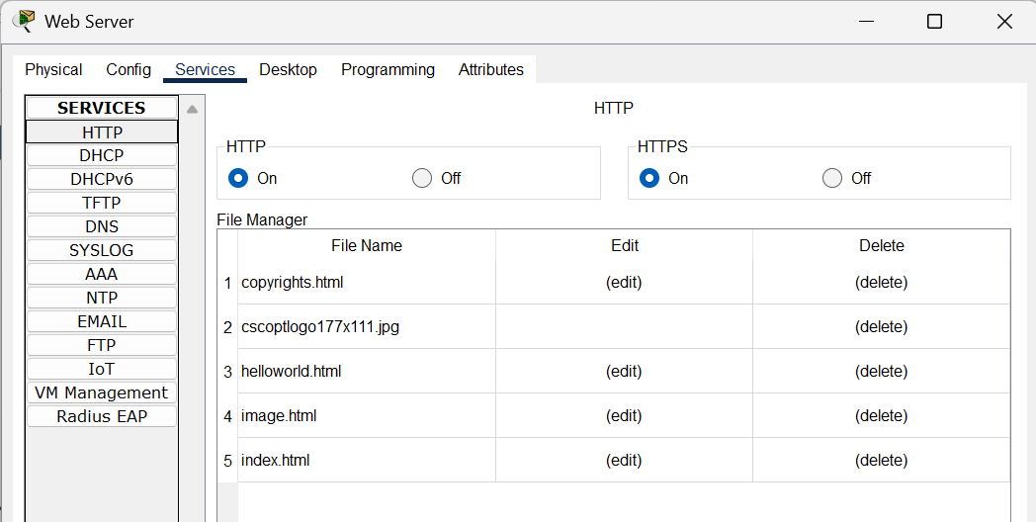

Fig 2. WEB server – HTTP Services

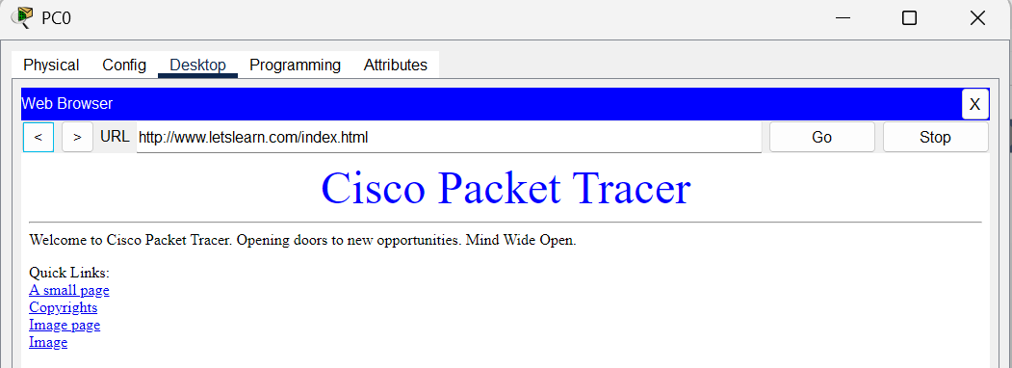

Fig 3. PC0 – accessing data from web browser

**Program 4:**

**Aim:** Configure IP address to routers in packet tracer. Explore the following messages: ping responses, destination unreachable, request timed out, reply.

**Topology:**



**Procedure:**

**1. Assign IP Addresses to Router Interfaces**

1. Click the Router → Config → Interfaces.
2. **Configure and enable:**
   * Fa0/0 → IP: 192.168.1.1 /24
   * Fa0/5 → IP: 192.168.2.1 /24

**3.Turn Port Status = On for each interface**.

2. Assign IP Addresses to PCs and Servers

1. On each device → Desktop → IP Configuration.
2. Use matching networks:
   * Devices connected to Fa0/0 → IP: 192.168.1.x, Gateway: 192.168.1.1
   * Devices connected to Fa0/5 → IP: 192.168.2.x, Gateway: 192.168.2.1

3. Verify Connectivity with Ping

1. Open PC → Desktop → Command Prompt.
2. Test different responses:
   * Ping reply → reachable IP
   * Request timed out → device powered off / link down
   * Destination unreachable → wrong gateway or missing route
3. Observe the output for each case.

Example commands:

ping 192.168.1.2

ping 192.168.1.101

ping 192.168.2.200

**Observation:**

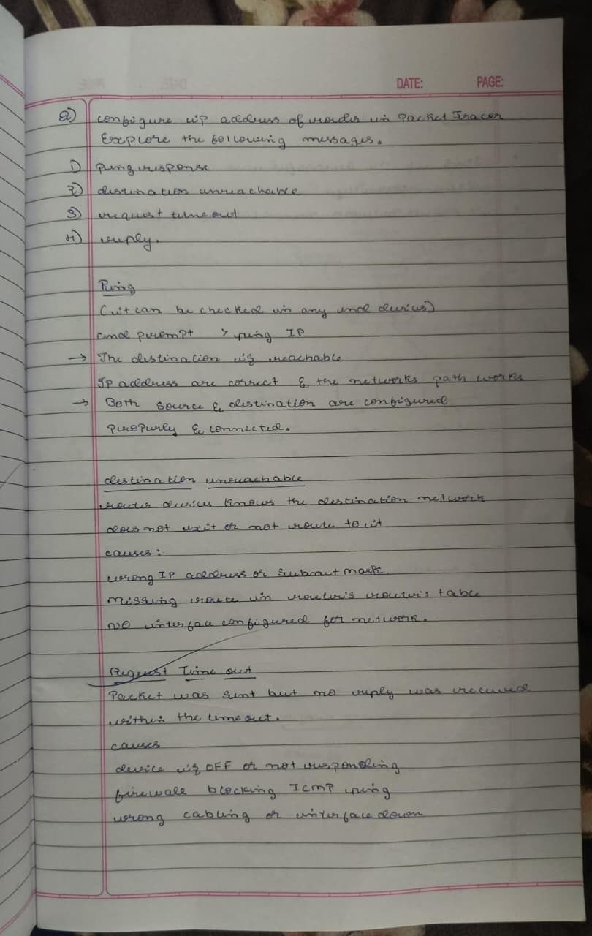

**Output:**

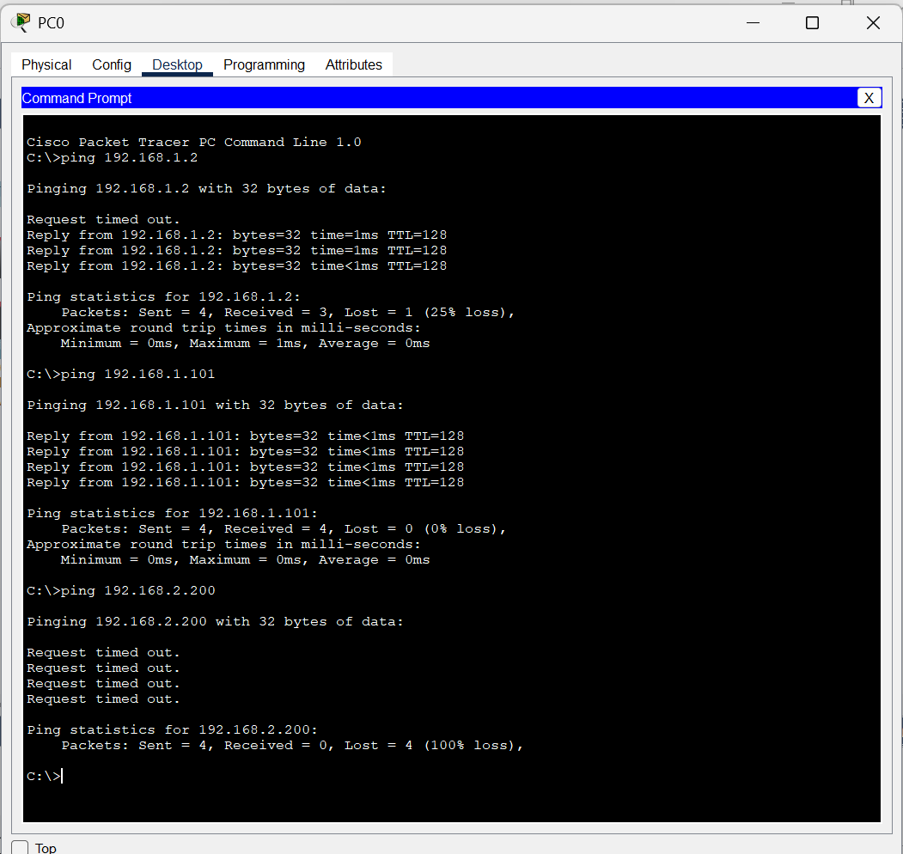

**Program 5:**

**Aim:** Configure default route, static route to the Router.

**Topology:**



**Procedure:**

**1. Assign IP Addresses**

1. On each router → Config → Interfaces
2. Set IP addresses for all FastEthernet and Serial interfaces according to the network diagram.
3. Turn Port Status = On for each interface.

**2. Configure Static Routes**

Perform on each router:

Router 2

1. Go to Config → Routing → Static
2. Add routes for networks behind Router 3 and Router 4:
   * Network: 192.168.3.0 /24 → Next Hop: 192.168.4.2
   * Network: 192.168.5.0 /24 → Next Hop: 192.168.4.2
   * Network: 192.168.6.0 /24 → Next Hop: 192.168.4.2
   * Network: 192.168.7.0 /24 → Next Hop: 192.168.4.2

Router 3

1. Go to Config → Routing → Static
2. Add routes toward Router 2 and Router 4:
   * 192.168.1.0 /24 → via 192.168.4.1
   * 192.168.2.0 /24 → via 192.168.4.1
   * 192.168.5.0 /24 → via 192.168.7.2
   * 192.168.6.0 /24 → via 192.168.7.2

Router 4

1. Go to Config → Routing → Static
2. Add routes toward Router 2 and Router 3:
   * 192.168.1.0 /24 → via 192.168.7.1
   * 192.168.2.0 /24 → via 192.168.7.1
   * 192.168.3.0 /24 → via 192.168.7.1
   * 192.168.4.0 /24 → via 192.168.7.1

**3. Configure Default Route (Optional)**

If needed, add:

0.0.0.0 /0 → next-hop IP

(from each router toward the main/central router)

**4. Test Connectivity**

1. On any PC → Command Prompt
2. Use ping to reach devices in other networks.
3. Successful reply = routing configured correctly.

**Observation**

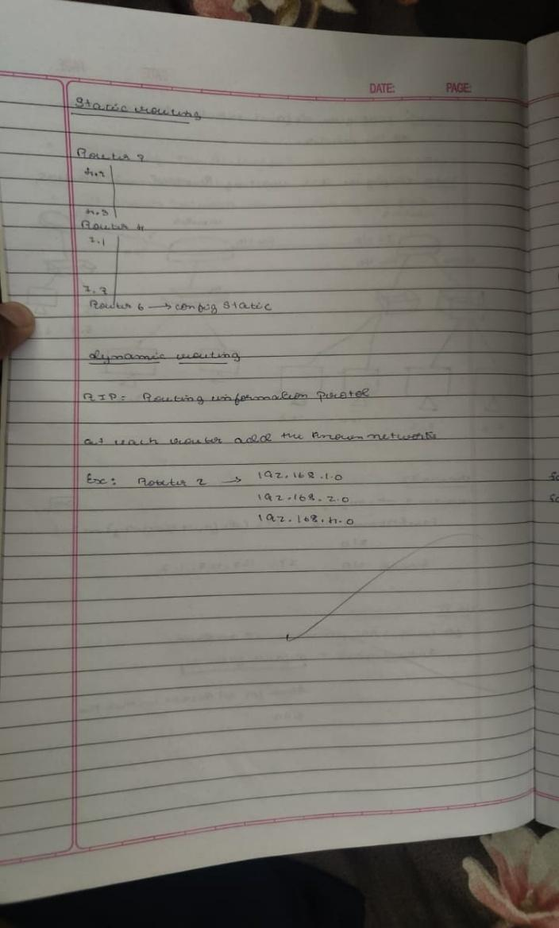

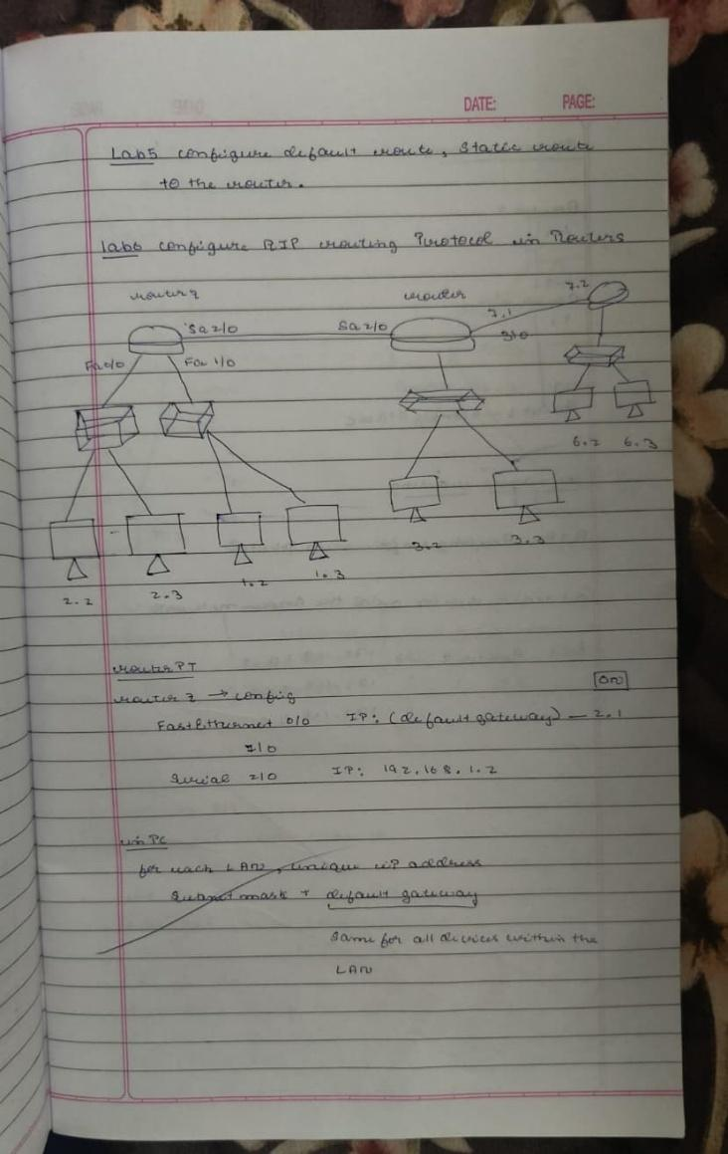

**Output:**

Fig 1. Router 2 – Static routing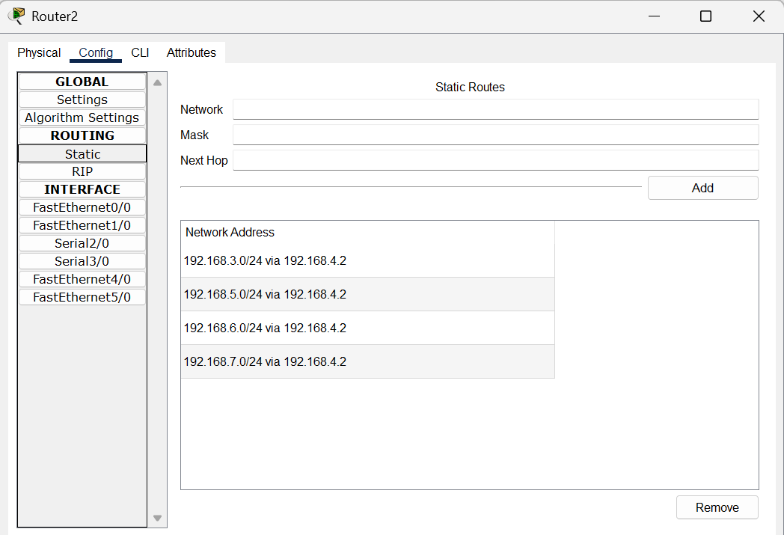

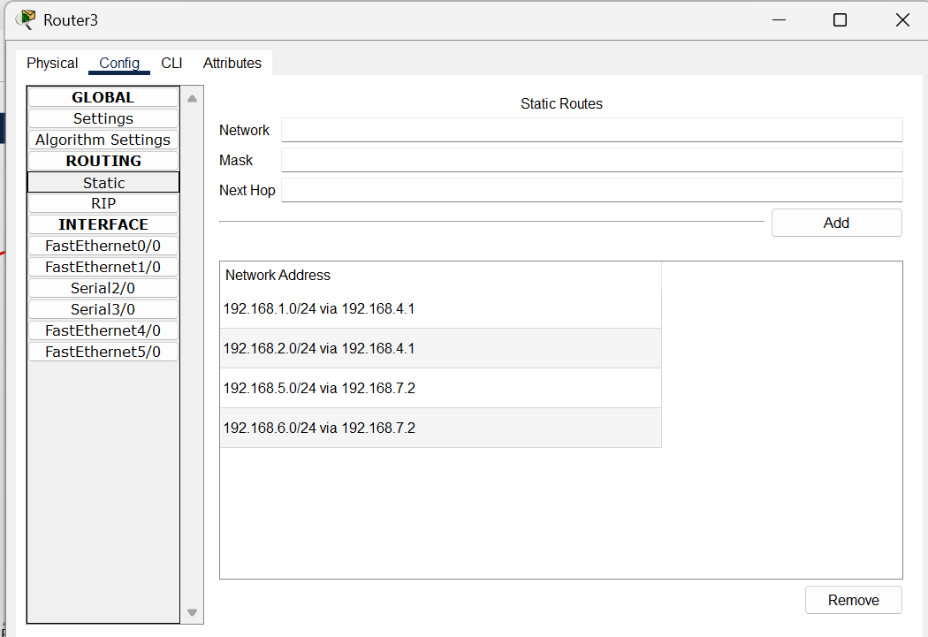

Fig 2. Router 3 – Static routing

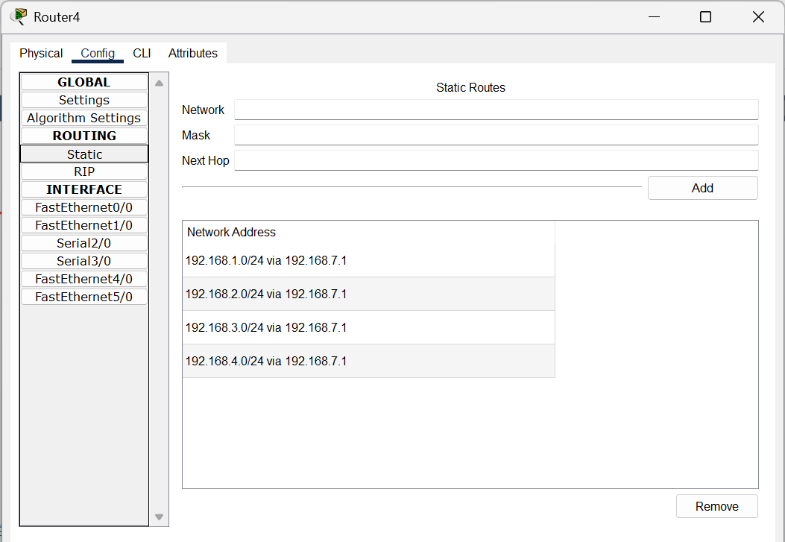

Fig 3. Router 4 – Static routing

**Program 6:**

**Aim:** Configure RIP routing Protocol in Routers.

**Topology:**



**Procedure**

**1. Assign IP Addresses**

1. On each router → Config → Interfaces
2. Configure IPs for all FastEthernet and Serial interfaces as per the network diagram.
3. Turn Port Status = On.

**2. Enable RIP on Each Router**

Router 2

1. Go to Config → Routing → RIP
2. Add directly connected networks:
   * 192.168.1.0
   * 192.168.2.0
   * 192.168.4.0

Router 3

1. Go to Config → Routing → RIP
2. Add networks:
   * 192.168.3.0
   * 192.168.4.0
   * 192.168.7.0

Router 4

1. Go to Config → Routing → RIP
2. Add networks:
   * 192.168.5.0
   * 192.168.6.0
   * 192.168.7.0

**3. Verify Routing**

1. On any router → CLI
2. Use:
3. show ip route

→ RIP routes should appear with the letter R.

4. Test Connectivity

1. From PCs across different networks, use:
2. ping <destination IP>
3. Successful replies confirm RIP routing is working.

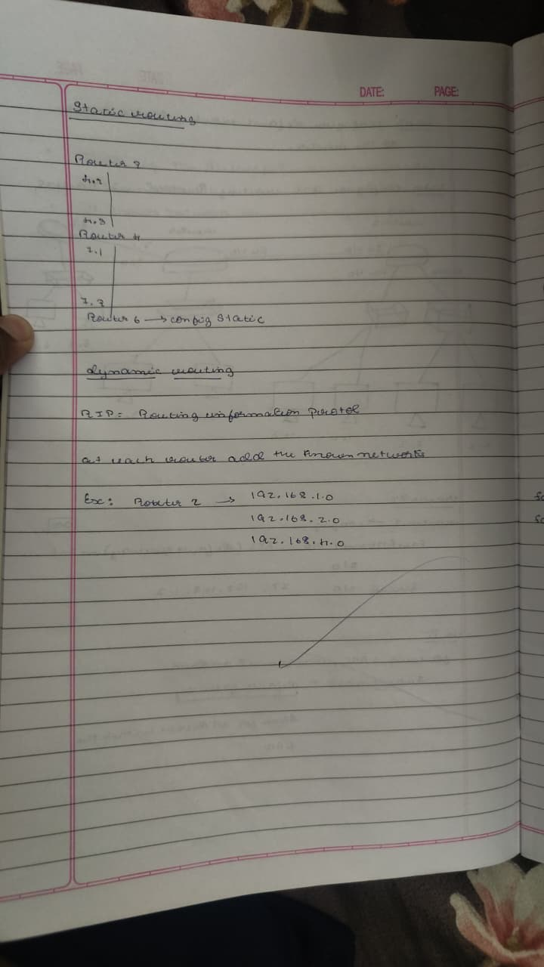**Observation**

**Output:**

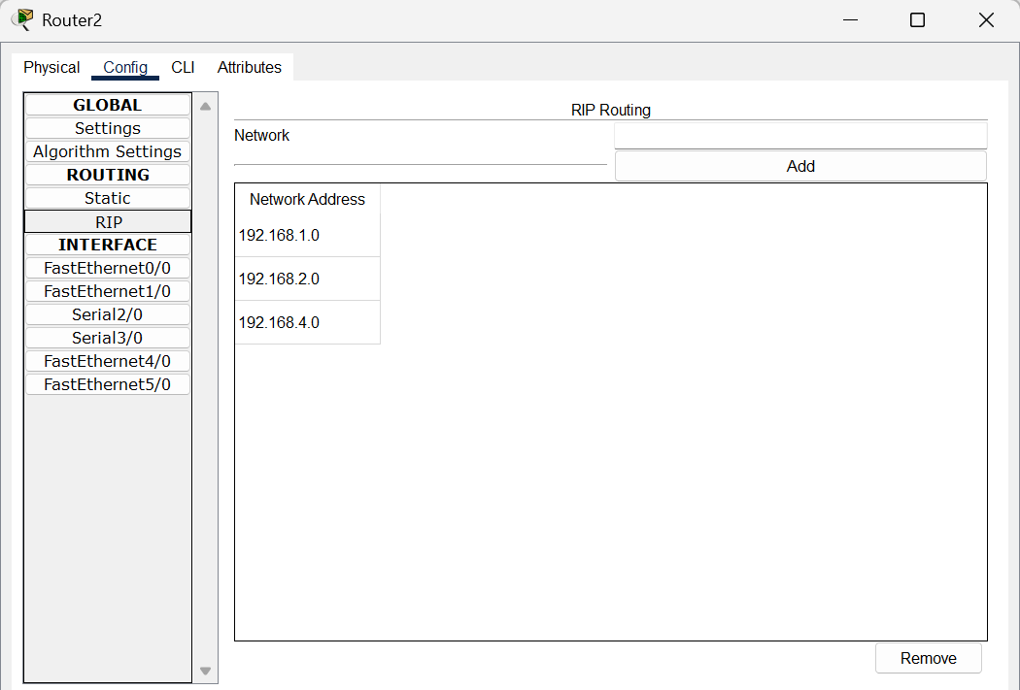

Fig 1. Router 2 – RIP routing

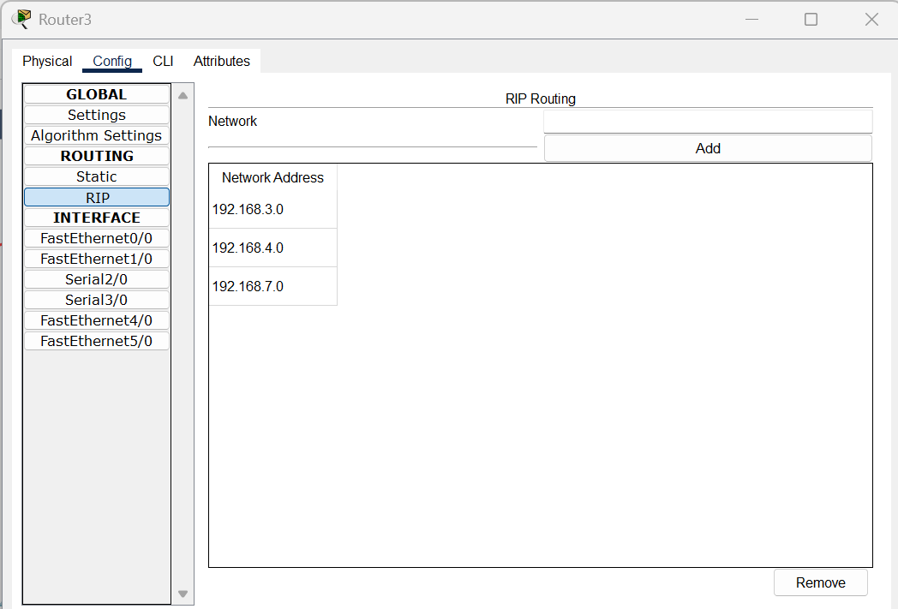

Fig 2. Router 3 – RIP routing

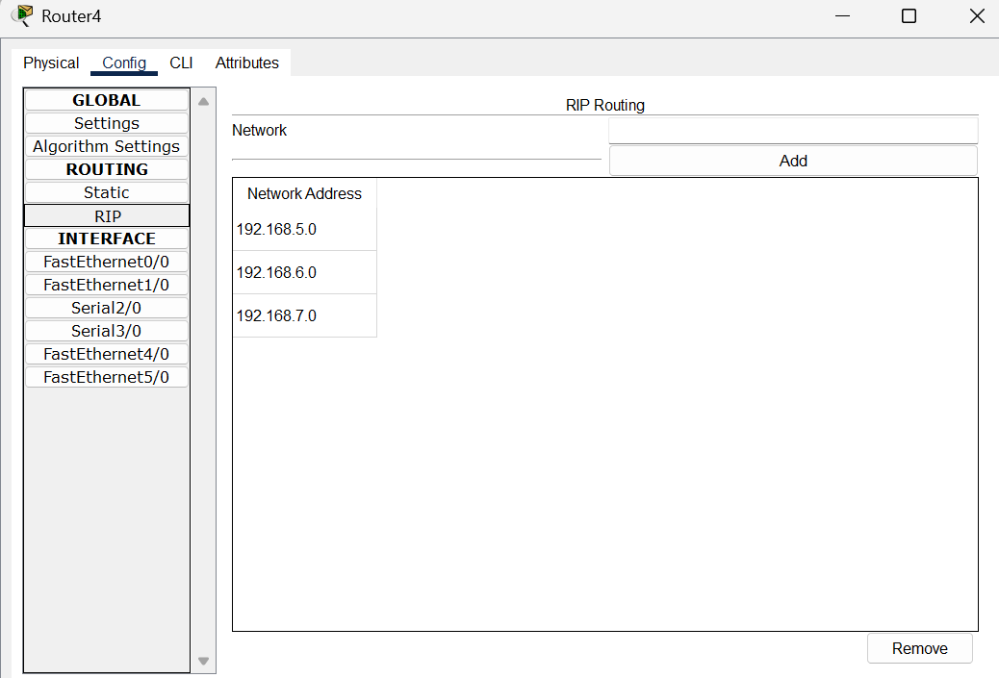

Fig 3. Router 4 – RIP routing

**Program 7:**

**Aim:** Configure OSPF routing protocol.

**Topology:**



**Procedure:**

**1. Assign IP Addresses**

1. On each router → Config → Interfaces
2. Assign IPs to Gig0/0, Gig0/1, and PC-facing interfaces as per the diagram.
3. Enable all interfaces (Port Status = On).

**2. Configure OSPF on All Routers**

Router 0

1. Go to Config → Routing → OSPF
2. Set Process ID = 1
3. Add networks:
   * 192.168.1.0 /24
   * 10.0.0.0 /30 (link to center router)

Router 1 (Center Router)

1. Process ID = 1
2. Add networks:
   * 10.0.0.0 /30 (left link)
   * 20.0.0.0 /30 (right link)

Router 2

1. Process ID = 1
2. Add networks:
   * 192.168.2.0 /24
   * 20.0.0.0 /30 (link to center router)

**3. Test Connectivity**

1. From PC0 → PC1, send PDU or use ping command.
2. Successful ICMP reply confirms OSPF is working.
3. **Observation:**

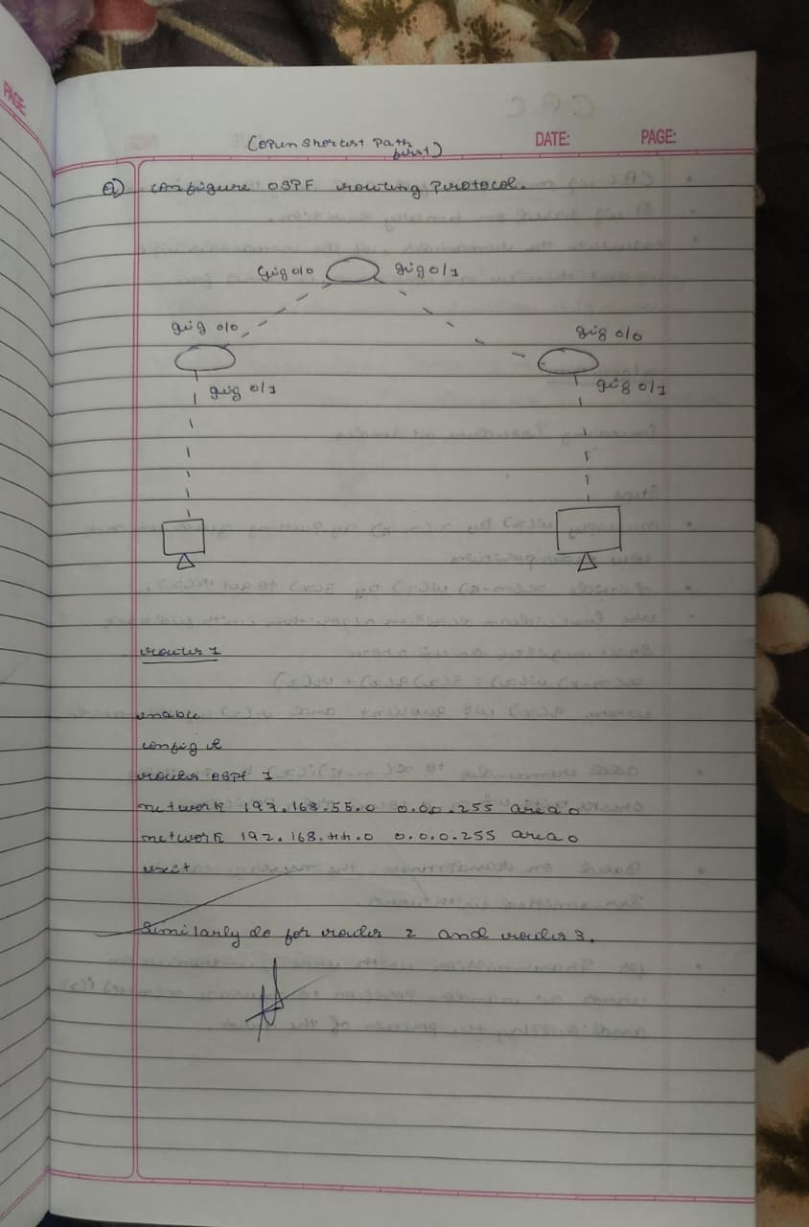

**Output:**

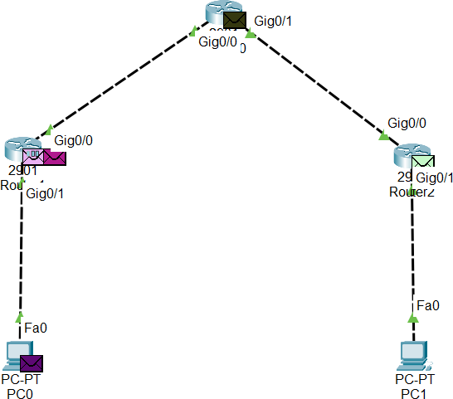

Fig 1. Sending PDU message from PC0 to PC1

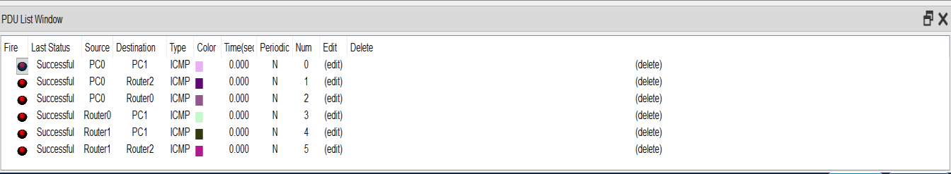

Fig 2. Checking PDU messages

**Program 8:**

**Aim:** To construct a VLAN and make the PC’s communicate among a VLAN.

**Topology:**



**Procedure:**

**1. Create VLANs on Both Switches**

1. Open each switch → Config → VLAN Database
2. Create VLANs (example):
   * VLAN 10
   * VLAN 20

**2. Assign Ports to VLANs**

Assign PCs to the required VLAN:

Switch 1 (Left Side)

* PC0 (Fa0/1) → VLAN 10
* PC1 (Fa0/2) → VLAN 10
* PC2 (Fa0/3) → VLAN 20

Switch 2 (Right Side)

* PC3 (Fa0/2) → VLAN 10
* PC4 (Fa0/3) → VLAN 10
* PC5 (Fa0/4) → VLAN 20

**3. Configure Trunk Between Switches**

1. Select the link between Fa0/4 (Switch1) ↔ Fa0/1 (Switch2)
2. On both ends → Config → Interface
3. Set Mode = Trunk
4. Allow VLANs 10 and 20 on the trunk.

**4. Assign IPs to PCs**

1. On each PC → Desktop → IP Configuration
2. Assign IPs in VLAN-specific networks (example):
   * VLAN 10 → 192.168.10.x
   * VLAN 20 → 192.168.20.x

**5. Test Connectivity**

1. Use Add Simple PDU or ping:
   * Devices in the *same VLAN* should communicate.
   * Devices in *different VLANs* should not communicate.

**Observation:**

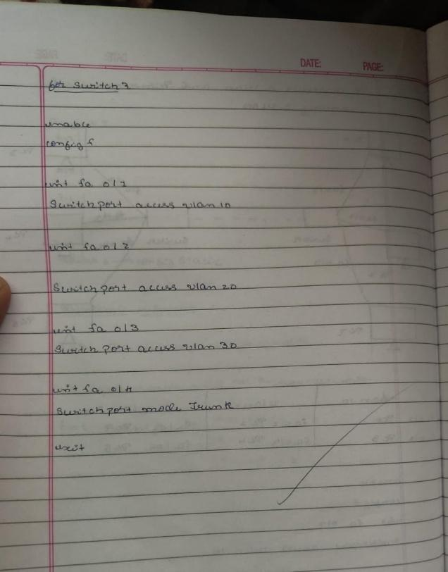

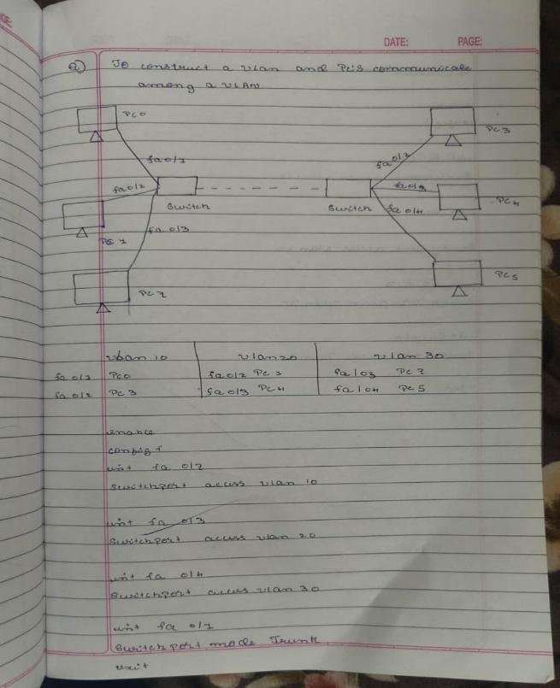

**Output:**

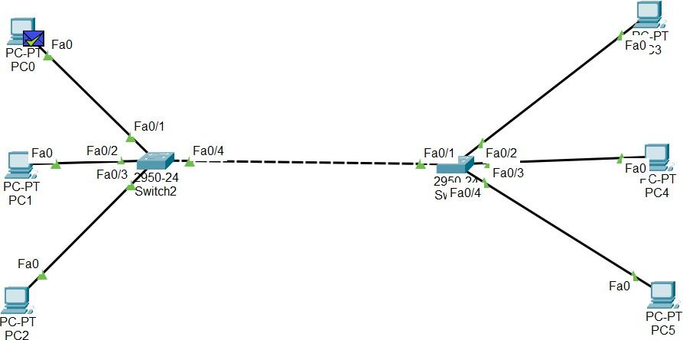

Fig 1. Sending PDU message from PC0 to PC5

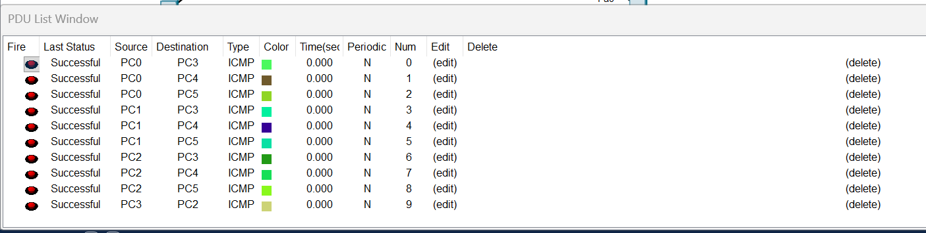

Fig 2. Checking PDU messages

**Program 9:**

**Aim:** To construct a WLAN and make the nodes communicate wirelessly.

**Topology:**



Configuration 1

Configuration 2

**Procedure:**

**1. Add Wireless Devices**

1. Place Wireless Router, Access Point, Laptops, Smartphones, and PCs as shown.
2. For laptops/PCs without wireless modules →
   * Power off → Insert Wireless NIC → Power on.

**2. Configure Wireless Router / Access Point**

1. Click the Wireless Router / AP → Config → Wireless
2. Set:
   * SSID = BMSCE
   * Authentication = WPA2-PSK
   * Passphrase = bmsce123
3. Keep channel and encryption default.

**3. Configure Wireless Settings on Laptop & Smartphone**

1. Open device → Desktop → PC Wireless / Wi-Fi
2. Select SSID BMSCE
3. Enter password bmsce123
4. Connect.

**4. Assign IP Addresses (if required)**

1. Use DHCP (automatic) or manually assign from the same network.

**5. Test Wireless Communication**

1. Use Add Simple PDU or ping between wireless devices.
2. Successful replies confirm WLAN communication.

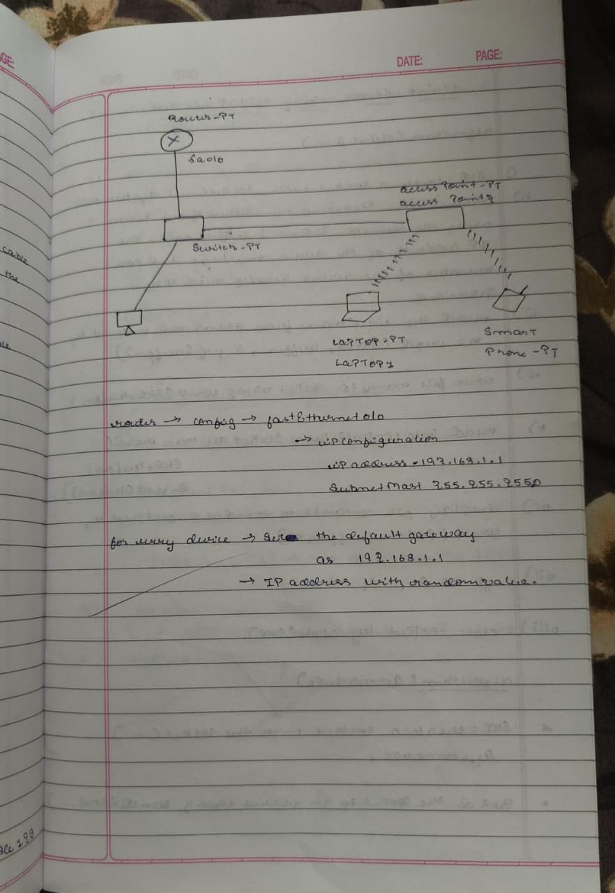**Observation:**

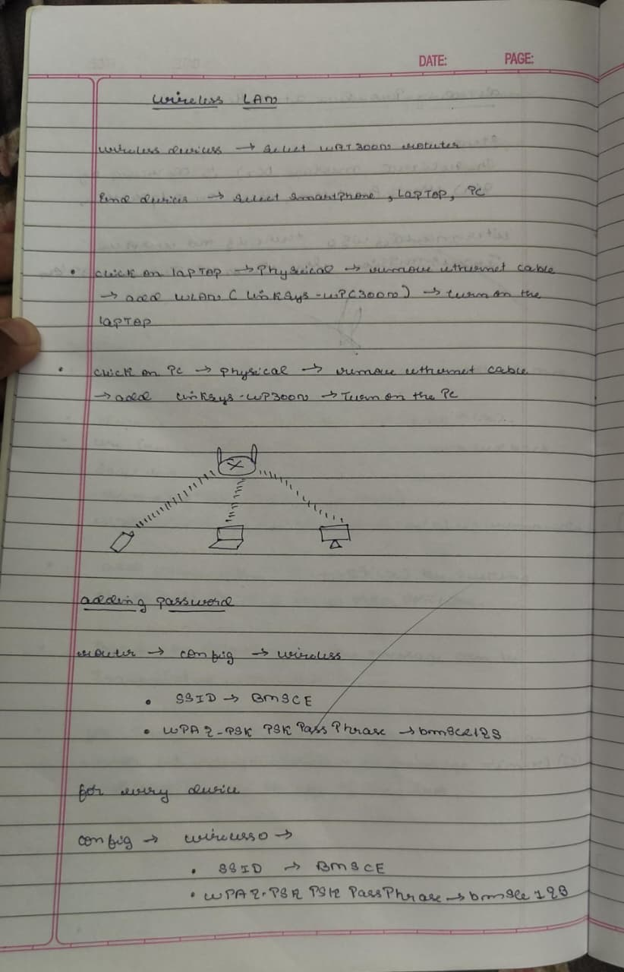

**Output:**

1. Do Physical Connections In:
   * Laptop
   * PC

| Fig 1.1 Step1: Turn off light / Power off laptop | Fig 1.2 Step2: Drag and Drop the Ethernet into pointed location |
| --- | --- |
| Fig 1.3 Step3: Drag and Drop the device into pointed location and Turn on light/Laptop | Fig 2. PC physical connection (combined 3 steps) |

1. Do Wireless Connection in:



| Fig 2. Config at Device Laptop0 | Fig 3. Config at Device Smartphone0 |
| --- | --- |

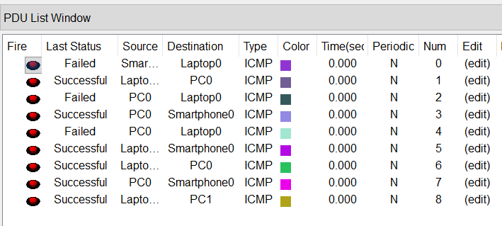

Fig 3. Checking PDU messages

**Program 10:**

**Aim:** Demonstrate the TTL/ Life of a Packet.

**Topology:**



**Procedure:**

**Create the Network**

1. Place one Router, one Switch, and two PCs as shown in the topology.
2. Connect:
   * Router → Switch (Fa0/0 to Fa0/1)
   * Switch → PC0 (Fa1/1)
   * Switch → PC1 (Fa2/1)

**2. Assign IP Addresses**

1. On each PC → Desktop → IP Configuration
   * PC0: 192.168.1.2 /24
   * PC1: 192.168.1.3 /24
   * Gateway: 192.168.1.1
2. On Router → Config → Interface Fa0/0
   * IP: 192.168.1.1 /24
   * Turn Port Status = On

**3. Switch to Simulation Mode**

1. Click Simulation Mode (bottom right).
2. Select Add Simple PDU tool.

**4. Send the Packet**

1. Click PC0 → then click PC1 to send an ICMP (ping) PDU.
2. Observe packet movement step-by-step.

**5. Check TTL (Time To Live)**

1. Click the PDU in the event list.
2. Open Inbound PDU Details and Outbound PDU Details.
3. Note the TTL value:
   * At source PC → TTL usually starts at 255
   * After passing Router → TTL reduces (example: 128)

**6. Observe TTL Decrement**

Each time a packet passes through a router, TTL decreases by 1, demonstrating the packet’s lifespan on the network.

**Observation:**

|  |  |
| --- | --- |

**Output:**

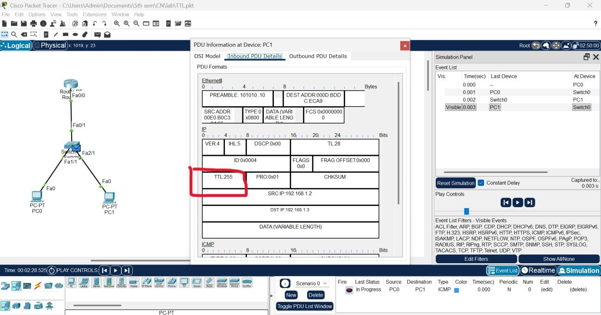

Fig 1. Inbound PDU Details at Device PC1

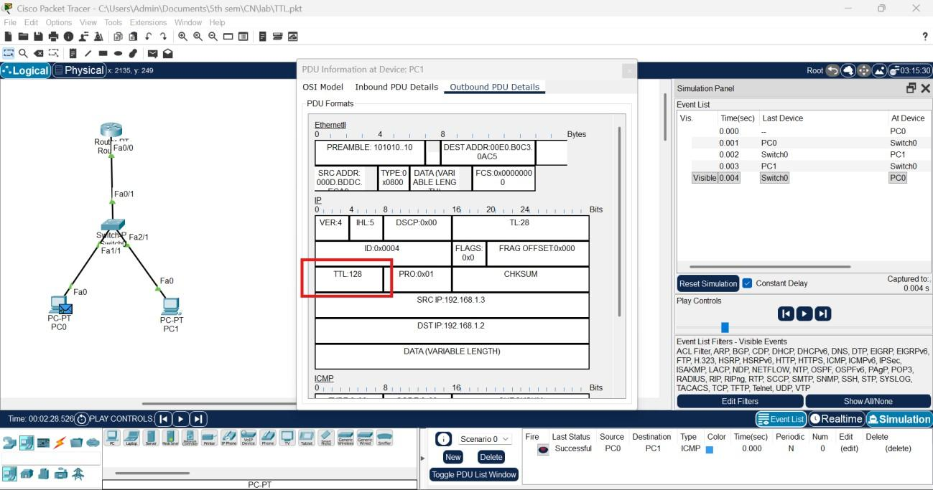

Fig 1. Outbound PDU Details at Device PC1

**Program 11:**

**Aim:** To understand the operation of TELNET by accessing the router in server room from a PC in IT office.

**Topology:**



**Procedure:**

**Procedure**

**1. Configure the Router for Telnet**

1. Open Router0 → CLI and enter:
2. enable
3. configure terminal
4. hostname R1
5. line vty 0 4
6. login
7. password cisco
8. enable secret tp
9. interface fa0/0
10. ip address 192.168.1.1 255.255.255.0
11. no shutdown
12. exit
13. end
14. Verify interface status:
15. show ip interface brief

**2. Assign IP to PC**

1. On PC0 → Desktop → IP Configuration:
   * IP Address: 192.168.1.2
   * Subnet Mask: 255.255.255.0
   * Gateway: 192.168.1.1

**3. Test Connectivity**

1. On PC0 → Command Prompt, ping the router:
2. ping 192.168.1.1

**4. Access Router Using Telnet**

1. On PC0 → Command Prompt:
2. telnet 192.168.1.1
3. Enter password: cisco to log in.
4. You now have remote access to the router.

**5. Verify Telnet Access**

1. Execute any router command remotely, e.g.:

show ip interface brief

**Observation:**

|  |  |
| --- | --- |

**Output:**

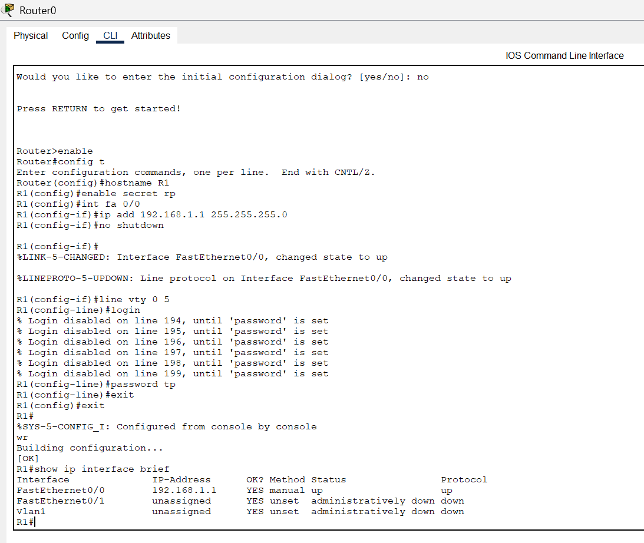

Fig 1. Router0 – CLI commands

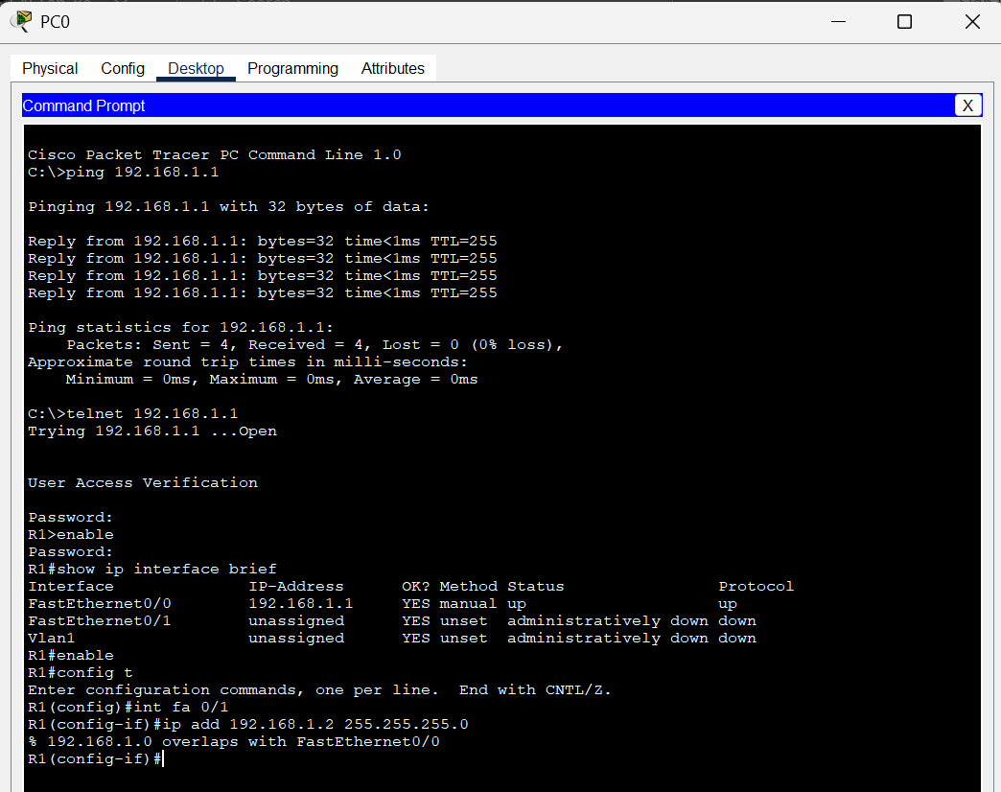

Fig2. PC command line prompt

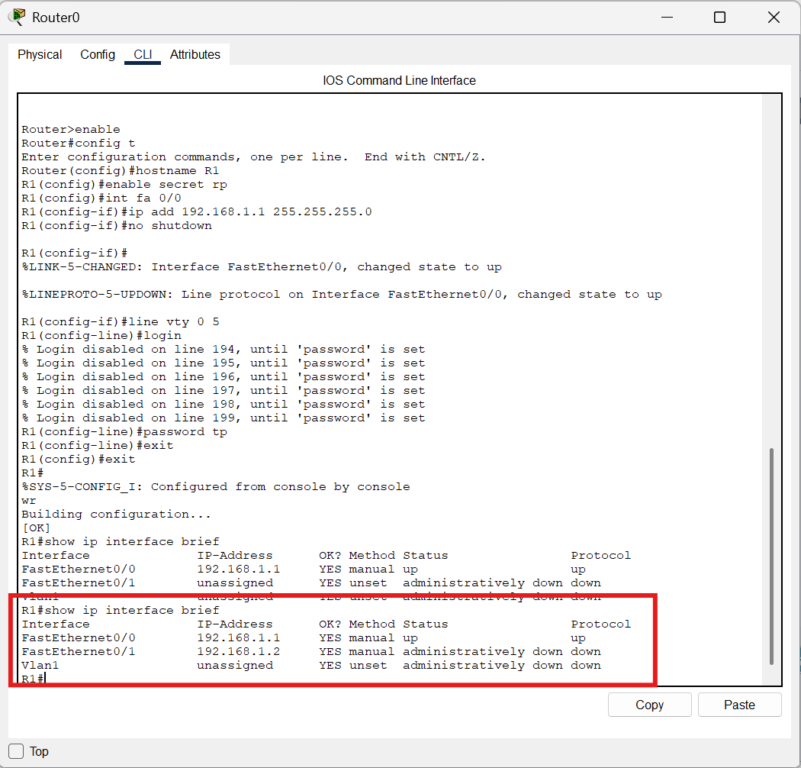

Fig 3. Updated the changes into Router0

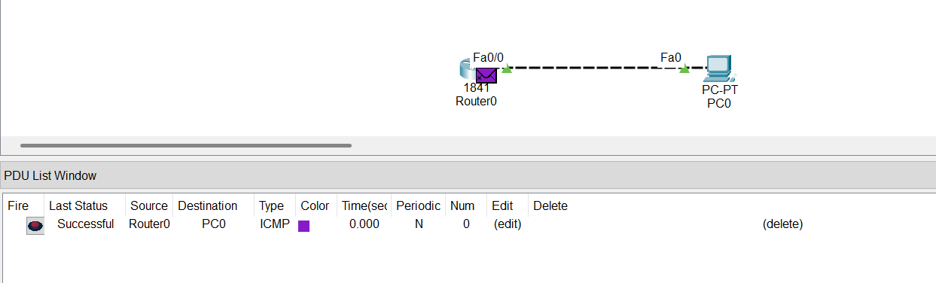

Fig 4. PDU message Successful

**Program 12:**

**Aim:** To construct simple LAN and understand the concept and operation of Address Resolution Protocol (ARP).

**Topology:**



**Procedure:**

**1. Create the LAN**

1. Place one server, one switch, and three PCs as shown.
2. Connect all devices to the switch using straight-through cables.

**2. Assign IP Addresses**

1. On each PC and the Server → Desktop → IP Configuration
   * Server: 192.168.1.1
   * PC0: 192.168.1.2
   * PC1: 192.168.1.3
   * PC2: 192.168.1.4
   * Subnet Mask: 255.255.255.0
   * Gateway: (none needed for LAN)

**3. Check ARP Table (Before Communication)**

1. On each device → Command Prompt
2. Type:
3. arp -a
4. The ARP table will be empty initially.

**4. Generate Traffic (Ping)**

1. On PC0 → Command Prompt:
2. ping 192.168.1.1
3. PC0 sends an ARP request → switch → server.
4. Server replies with its MAC address.

**5. Check ARP Table (After Communication)**

1. On each device, again run:
2. arp -a
3. Entries now appear showing:
   * IP Address
   * MAC Address
   * Interface

This demonstrates how ARP resolves IP → MAC mapping.

**Observation:**

|  |  |
| --- | --- |

**Output:**

| Fig 1.1 ARP table at Server0 | Fig 1.2 Command Prompt at Server0 |
| --- | --- |
| Fig 2.1 ARP table at PC0 | Fig 2.2 Command Prompt at PC0 |
| Fig 3.1 ARP table at PC1 | Fig 3.2 Command Prompt at PC1 |

| Fig 4.1 ARP table at PC2 | Fig 4.2 Command Prompt at PC2 |
| --- | --- |

# PART - B

**Program 1:**

**Aim:** Write a program for congestion control using Leaky bucket algorithm.

**Code:**

#include <stdio.h>

int min(int x, int y) { if (x < y)

return x; else

return y;

}

int main() {

int drop = 0, mini, nsec, cap, count = 0, i, inp[25], process;

printf("Enter the bucket size:\n"); scanf("%d", &cap);

printf("Enter the processing rate:\n"); scanf("%d", &process);

printf("Enter the number of seconds you want to simulate:\n");

scanf("%d", &nsec);

for (i = 0; i < nsec; i++) {

printf("Enter the size of the packet entering at %d sec:\n", i + 1);

scanf("%d", &inp[i]);

}

printf("\nSecond | Packet Received | Packet Sent | Packet Left | Dropped\n");

printf("

\n");

for (i = 0; i < nsec; i++) { count += inp[i];

if (count > cap) {

drop = count - cap; count = cap;

}

printf("%d\t %d\t\t", i + 1, inp[i]);

mini = min(count, process); printf("%d\t\t", mini);

count = count - mini; printf("%d\t\t %d\n", count, drop);

drop = 0;

}

// Remaining packets after time ends for (; count != 0; i++) {

if (count > cap) {

drop = count - cap; count = cap;

}

printf("%d\t 0\t\t", i + 1);

mini = min(count, process); printf("%d\t\t", mini);

count = count - mini; printf("%d\t\t %d\n", count, drop);

drop = 0;

}

return 0;

}

**Output:**

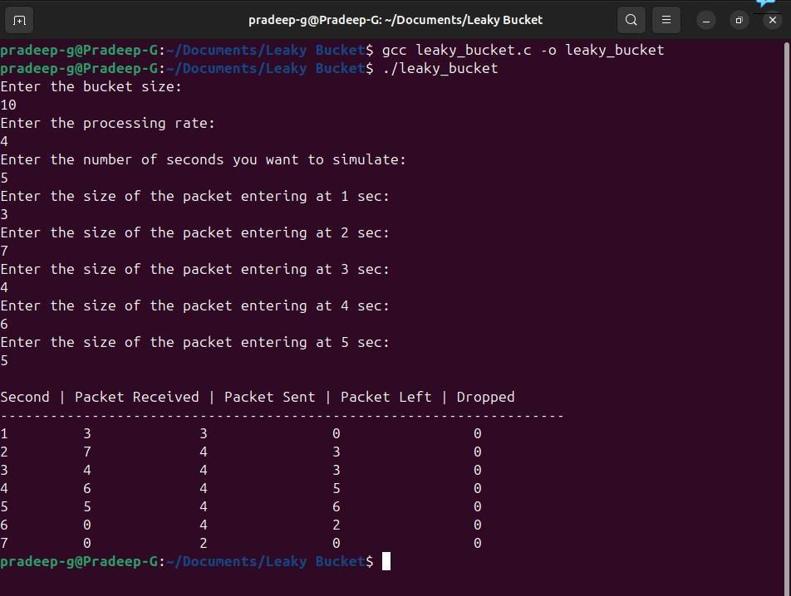

**Observation:**

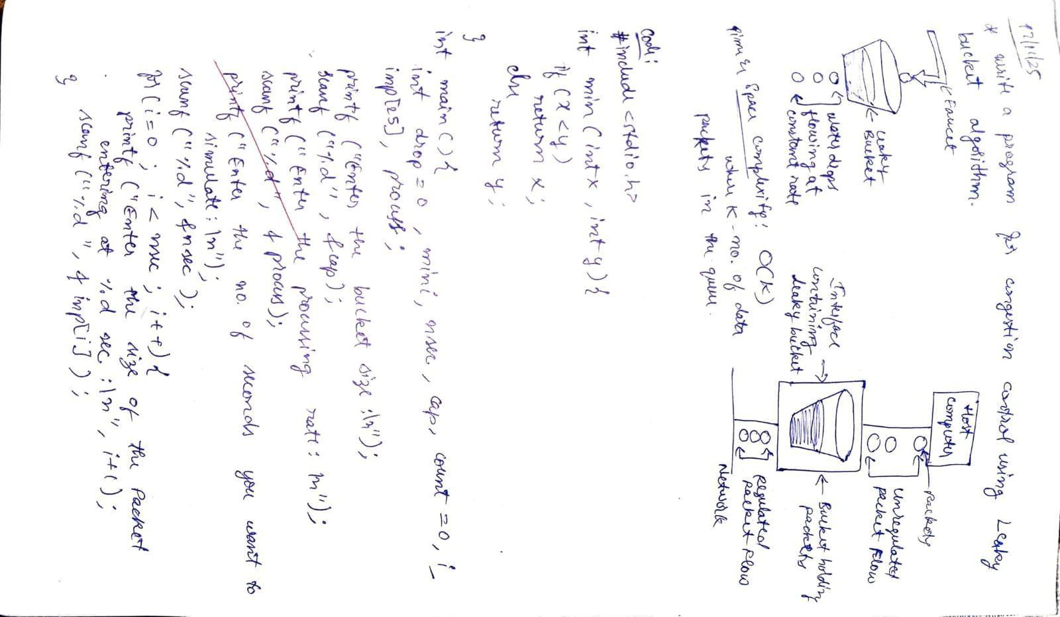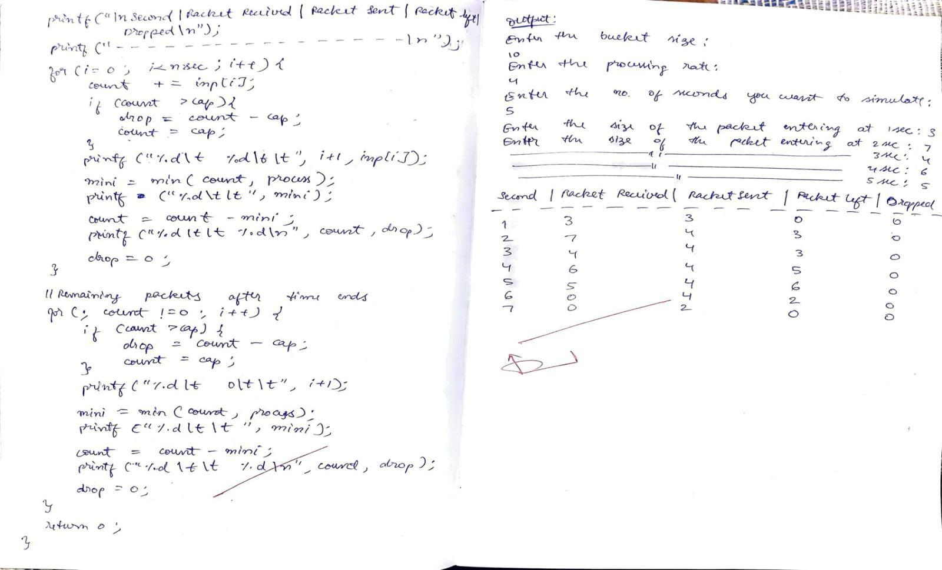

**Program 2:**

**Aim:** Using TCP/IP sockets, write a client-server program to make client sending the file name and the server to send back the contents of the requested file if present.

**Code:**

| # tcp_client.py  import socket  # Step 1: Create TCP socket  client_socket = socket.socket(socket.AF_INET, socket.SOCK_STREAM)  # Step 2: Connect to server  client_socket.connect(('localhost', 8080))  # Step 3: Send filename  filename = input("Enter filename to request: ")  client_socket.send(filename.encode())  # Step 4: Receive file contents  data = client_socket.recv(4096).decode()  print("\n--- File Content ---\n") print(data)  # Step 5: Close connection client_socket.close() | # tcp_server.py import socket  # Step 1: Create a TCP socket server_socket = socket.socket(socket.AF_INET, socket.SOCK_STREAM)  # Step 2: Bind to address and port server_socket.bind(('localhost', 8080))  # Step 3: Listen for client connections server_socket.listen(1) print("Server is listening on port 8080...")  # Step 4: Accept connection  conn, addr = server_socket.accept() print("Connected by:", addr)  # Step 5: Receive file name filename = conn.recv(1024).decode().strip()  try:  # Step 6: Open and read file with open(filename, 'r') as f:  data = f.read()  conn.send(data.encode()) # Send file contents  except FileNotFoundError: conn.send(b"File not found on  server.")  # Step 7: Close connection conn.close() server_socket.close() |
| --- | --- |

**Output:**

Server side Terminal:

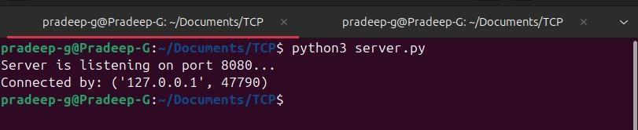

Client side Terminal:

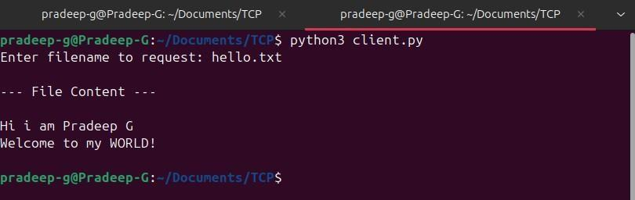

**Observation:**

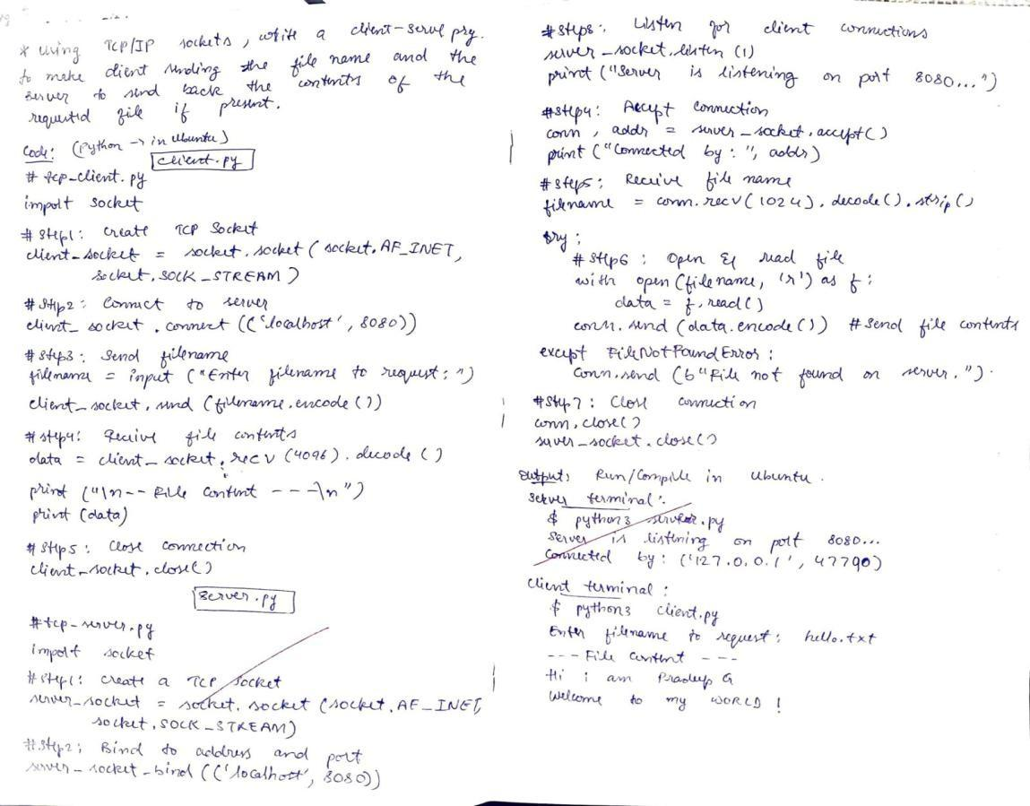

**Program 3**:

**Aim:** Using UDP sockets, write a client-server program to make client sending the file name and the server to send back the contents of the requested file if present.

**Code:**

| # udp_client.py  import socket  # Step 1: Create UDP socket  client_socket = socket.socket(socket.AF_INET, socket.SOCK_DGRAM)  server_address = ('localhost', 8081)  filename = input("Enter filename to request: ")  # Step 2: Send filename to server  client_socket.sendto(filename.en code(), server_address)  # Step 3: Receive response  data, addr = client_socket.recvfrom(4096)  print("\n--- File Content ---  \n") print(data.decode())  # Step 4: Close socket client_socket.close() | # udp_server.py import socket  # Step 1: Create UDP socket server_socket = socket.socket(socket.AF_INET, socket.SOCK_DGRAM)  # Step 2: Bind to address and port server_socket.bind(('localhost', 8081))  print("UDP Server is ready...") while True:  # Step 3: Receive filename  from client  filename, addr = server_socket.recvfrom(1024)  filename = filename.decode().strip()  print(f"Requested file:  {filename}")  try:  # Step 4: Open file and send content  with open(filename, 'r')  as f:  data = f.read()  server_socket.sendto(data. encode(), addr)  except FileNotFoundError: server_socket.sendto(b"Fil  e not found on server.", addr) |
| --- | --- |

**Output:**

Server side Terminal:

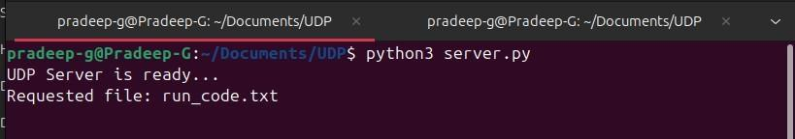

Client side Terminal:

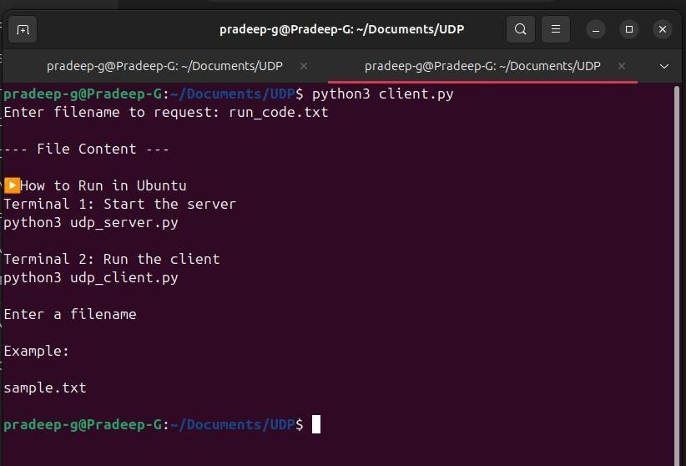

**Observation:**

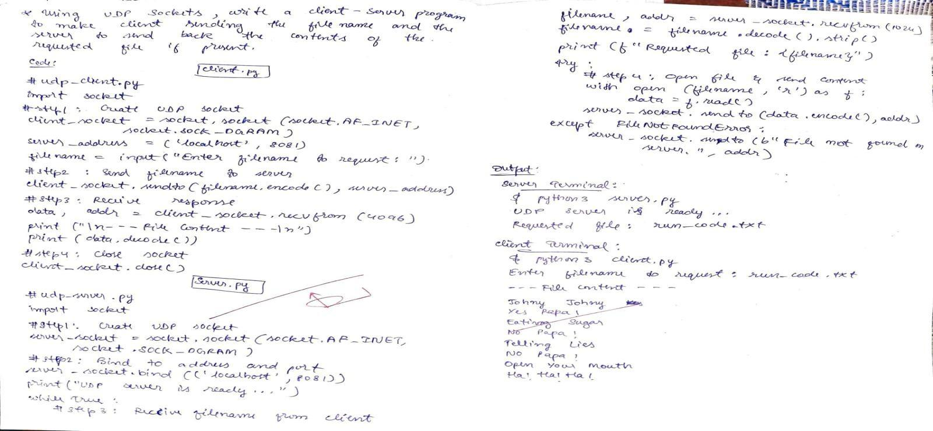

**Program 4:**

**Aim:** Write a program for error detecting code using CRC-CCITT (16-bits).

**Code:**

#include <stdio.h> #include <string.h> #include <stdlib.h>

int main() {

char rem[50], a[50], s[50], c, msj[50], gen[30]; int i, genlen, t, j, flag = 0, k, n;

printf("Enter the generation polynomial:\n"); gets(gen);

printf("Generator polynomial is CRC-CCITT: %s\n", gen);

genlen = strlen(gen); k = genlen - 1;

printf("Enter the message:\n"); n = 0;

while ((c = getchar()) != '\n') { msj[n] = c;

n++;

}

msj[n] = '\0';

for (i = 0; i < n; i++) a[i] = msj[i];

for (i = 0; i < k; i++) a[n + i] = '0';

a[n + k] = '\0';

printf("\nMessage polynomial appended with zeros:\n"); puts(a);

for (i = 0; i < n; i++) { if (a[i] == '1') {

t = i;

for (j = 0; j <= k; j++) { if (a[t] == gen[j])

a[t] = '0';

else

t++;

}

}

}

a[t] = '1';

for (i = 0; i < k; i++) rem[i] = a[n + i];

rem[k] = '\0';

printf("Checksum (remainder):\n"); puts(rem);

printf("\nMessage with checksum appended:\n"); for (i = 0; i < n; i++) a[i] = msj[i];

for (i = 0; i < k; i++) a[n + i] = rem[i];

a[n + k] = '\0'; puts(a);

n = 0;

printf("Enter the received message:\n"); while ((c = getchar()) != '\n') {

s[n] = c; n++;

}

s[n] = '\0';

for (i = 0; i < n; i++) { if (s[i] == '1') {

t = i;

for (j = 0; j <= k; j++, t++) { if (s[t] == gen[j])

s[t] = '0';

else

}

}

}

s[t] = '1';

for (i = 0; i < k; i++) rem[i] = s[n + i];

rem[k] = '\0';

for (i = 0; i < k; i++)

if (rem[i] == '1') flag = 1;

}

if (flag == 0)

printf("Received polynomial is error-free \n"); else

printf("Received polynomial contains error \n");

return 0;

}

**Output:**

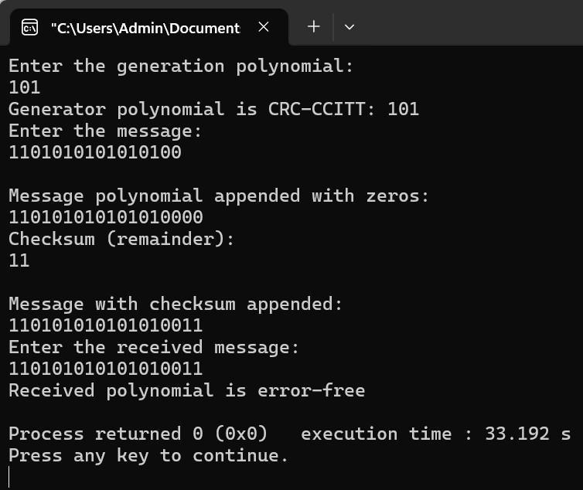

**Observation:**

